Beetles and Bullies
Wolfram Pyta, a history professor at the University of Stuttgart, and historians, Nils Havemann and Jutta Braun, wrote the book, Porsche: From design office to global brand. The book traces the history of the Volkswagon from the founding of the company in Stuttgart on April 25, 1931. I do not recall reading or hearing anything about it in the media, but April 25, 2021 marked the 90th anniversary of the Volkswagon company. It would be five years, however, before Adolf Hitler would be able to sit in the first VW Beetle, a convertible. That was 1936 in Stuttgart. Much more information is available on the internet and I tried to glean pertinent details that would be of interest to North American fans of these vehicles. There is also a dark side to this history. Adolf Hitler and Ferdinand Porsche were the driving forces behind the Volkswagen. Porsche was the genius engineer and Hitler the politician.
Ferdinand Porsche was born September 3, 1875 and remained a citizen of Austria (or Austria-Hungary) until 1918. At 27, Porsche had already become quite well known for his technological genius and inventions. In 1902 he was drafted into military service and served as a chauffeur to Archduke Franz Ferdinand of Austria. The Archduke’s assassination in Sarejevo, Yougoslavia sparked World War I a decade later. The Austro-Hungarian Empire broke up at the end of World War I. Because Porsche was born in Bohemia, he chose Czechoslovak citizenship in 1918. In 1934, Adolf Hitler (who was also Austrian by birth) made Porsche a naturalized German citizen. Porsche died in Stuttgart at 75 years of age in 1951.

Wolfsburg
Wolfsburg, Germany was planned and founded specifically for an automobile manufacturing plant and its workers. The city was officially opened in the year of my birth, 1938. Until May 25, 1945, the city was called Stadt des KdF-Wagens bei Fallersleben. KdF stands for “Kraft durch Freude,” which means “Strength Through Joy." A strict translation would be City of the Strength Through Joy Car near Fallersleben. As anyone can imagine, few residents of the new city rejoiced at having to write all those words into the address line of letters and in official documents. The city and Volkswagen factory were captured on April 11, 1945 by US troops and about 7,700 forced labourers were liberated. US troops occupied the city until the end of June and it was during this time that the city was renamed. Wolfsburg was the name of a castle that was first mentioned in 1302. On May 25th, the entire region became part of the British occupation zone.

The population of Wolfsburg increased from about 1,000 in 1938, to 25,000 by 1950 and in 1958, there were 50,000 inhabitants. In 1972, Wolfsburg passed the 100,000 mark when several adjacent villages were incorporated into the city. At the end of 2012, the population was 123,144 and the following year, Wolfsburg ranked as the richest city in Germany with a GDP per capita income of $128,000.
In 1955, the one-millionth VW Beetle was manufactured in Wolfsburg. Postwar Beetle production ended in Wolfsburg in 1974, but Beetle production continued within Germany at Emden until 1978. The last Beetle was delivered from the factory in Pueblo, Mexico in 2019. The factories in Wolfsburg remain a key part of Volkswagen's production capacity.
Most European cities boast a medieval city center but Wolfsburg features a new and modern attraction called the Autostadt. The Autostadt (“Car City”) is an open-air museum-theme park dedicated to automobile marks owned and built by Volkswagen. In the center of the park are the pavilions featuring Volkswagen's major brands: Volkswagen and Audi to the north, further south are SEAT, Škoda, Lamborghini, Bentley, Bugatti and the Premium Clubhouse. Right next to the lagoon is the Porsche pavilion. The Commercial Vehicles Pavilion is in the south-east of the park. The Autostadt also includes a planetarium; a Ritz-Carlton Hotel; the largest hands-on science museum in Germany (Phaeno Science Center); a water skiing resort; and a private art museum (Kunstmuseum Wolfsburg) that specialises in modern and contemporary art. Another major attraction is the Wolfsburg Water Show, the world's largest water-flame-laser-video fountain show with its over 200 foot high fountains.
VW Transporters
Production of the vehicle that would become the "workhorse of Germany" began in 1950 in Wolfsburg. When the hundred thousandth Bulli came off the assembly line in 1954, however, it was clear that the Transporter needed its own dedicated plant. Production capacity at the main Wolfsburg plant was no longer sufficient to meet demand. Alongside Beetle production, it was only possible to manufacture 80 Bullis per day, but 330 were needed.
I already mentioned that Wolfsburg was officially opened in 1938, the year of my birth. The first Volkswagon transporters (now lovingly called “Bulli” in German speaking Europe) rolled off the assembly line in Wolfsburg on my 12th birthday, March 8, 1950. In 1951 VW added the 43-window Samba, followed by a pickup (Pritsche) in 1952. The distinctive two-piece windscreen design of transporters up until 1967 led to the nickname “splittie” or “split window van” by fans the world over.
Transporters used the same 32 HP 4-cylinder air-cooled motor that powered the Beetle and were not expected to sell that well. After the war, however, the need for transport vehicles was great and money was in short supply. Production capacity in Wolfsburg could not keep pace with the demand of Beetles and the situation became more accute when production of transporters began. By 1954, the Commercial Vehicles devision decided to build a super plant elsewhere in Germany. As word leaked out that Volkswagon planned to build a huge plant, 235 cities and municipalities applied for the priviledge of hosting this gigantic project. Hannover – Stöcken was selected and no time was wasted to begin construction.
Construction of the new plant began in the cold, snowy February of 1955 with 372 workers. By the end of March, 1,000 workers were busy on the construction site. Planks had to be laid over the soft, muddy ground so trucks could deliver materials. On the site itself, a small, makeshift town grew with offices, huts for accommodation, canteen tents and shops of enterprising businesses who were quick to recognize opportunity.
It was the largest production hall in Europe at the time and sprang up in the space of just one year. It marked the beginning of a unique era in vehicle manufacturing and the T series soon became a symbol of the "economic miracle" of post-war Germany. 28 giant cranes were in continuous operation and 22 large cement mixers churned out over 6.5 thousand cubic yards of concrete daily. More than 2.3 million cubic yards of earth were moved.
During construction of the Hanover plant, Volkswagen was also training new employees for Transporter production. Every day 3000 “apprentices” took specially chartered trains to Wolfsburg, where they received necessary training in producing the “Bulli.” The Hanover factory was completed on March 8, 1956 - on my 18th birthday! Only one year after construction began, 4,000 employees were producing 230 Transporters per day!
Jobs at the new Volkswagen plant were highly coveted. They paid more than twice the typical wage in other jobs: an average hourly wage of 2.50 German Marks instead of 1.20 German Marks elsewhere. In the 1950s, many people quit their secure jobs in order to work at the the new Transporter plant in Hanover.
Within weeks after completion of the buildings, bodywork construction began. In 1962, Volkswagen celebrated production of the millionth “Made in Hanover” VW Transporter.
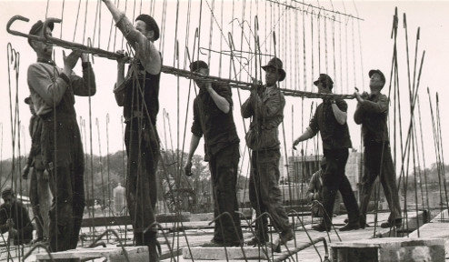
Construction work at the Hannover plant in 1955

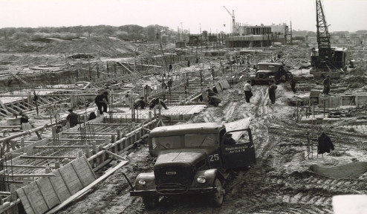
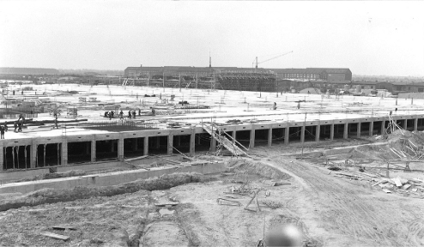
The basement a few weeks after construction work started
Finished Hannover factory in 1956 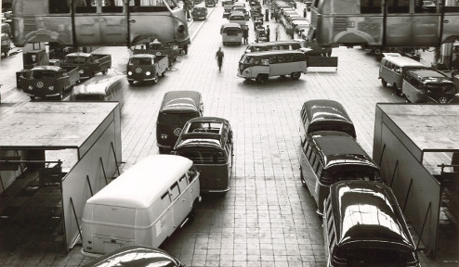
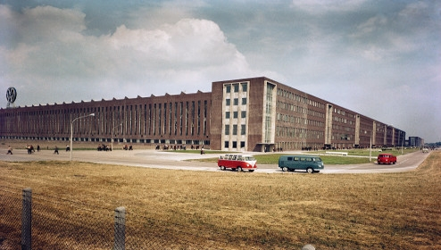
Commercial Vehicles plant in Hannover, 2016, with 14,500 employees!
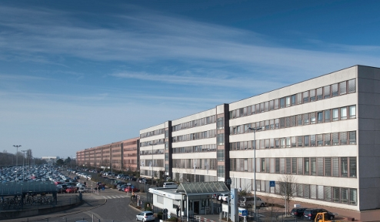
My Volkswagens
Prior to our trip to Europe for missionary service in July, 1964, I had owned over 40 cars. Some of them were hot rods and others customized, but most were purchased, repaired and sometimes repainted to sell. I financed a good part of my college education that way.
We spent the first two years in Europe studying German and for much of that time we had no car. In September, 1965, I bought a blue 1952 VW Beetle for $120. It had a 28 HP air-cooled boxer motor and unsynchronized 4-speed transmission. The body had a folding sunroof and split rear window giving it the nickname “pretzel.”
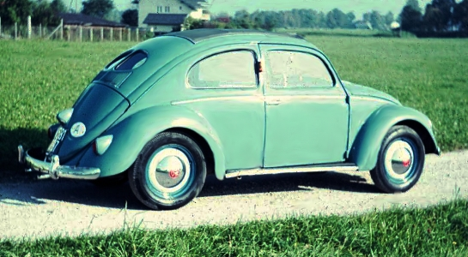
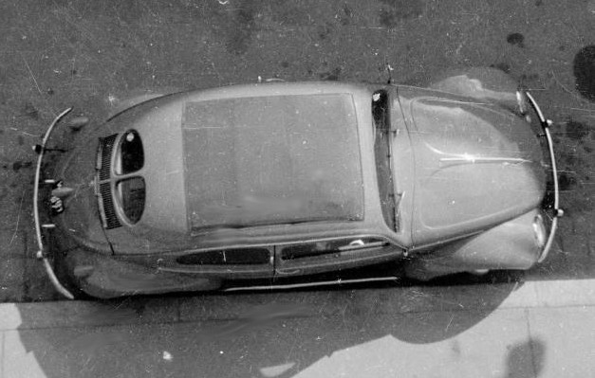
It otherwise looked much like later Beetles, but if you looked carefully, you could see “winkers” - signal lights that popped out of a panel behind the doors when needed (mine had been changed to a later style). In 1966, I gave the ‘52 to a pastor who used it for spare parts and purchased a 1957 “Samba Bus.”
As already stated above, production of the transporters began in Hanover on my 18th birthday, March 8, 1956. My ’57 Samba could well have been among the first 100 built! It was a Sealing Wax Red color with a Chestnut Brown top. This nine-passenger luxury version of the transporter sported a full folding sunroof, extra chrome trim, and 23 windows. That 23-window count includes eight skylights (four on each side of the vehicle), two curved rear windows, a window in the rear hatch, five windows on each side and the front split windshield. Actually, I counted 47 windows because there were two sliding panes and a vent window in the front doors. I had to wash all those windows, so I know!
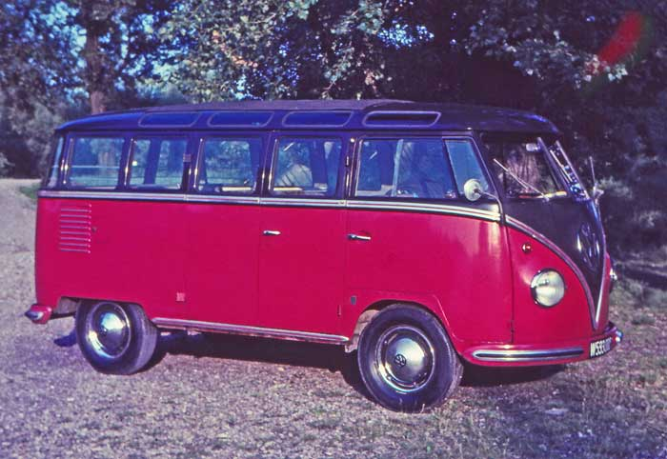
The Samba also had a double floor which served two purposes. The lower floor kept the upper floor from rusting through, but the second purpose was even more important. Every Volkswagen came with a heater. A pair of hollow metal tanks were fastened to the sides of the boxer engine that the exhaust pipes passed through. Warmed air was blown to the front of the vehicle to keep the windshield clear in winter. If you had a Beetle, you might be fortunate enough to get some heat in the interior of the vehicle, but an 8 or 9-passenger transporter needed all the warm air to keep the windshield clear. People also produce heat, but they also breathe and that increases condensation on the windows. The Samba’s heat duct was insulated and placed between the two floors. Because the Samba was more expensive, tourist agencies bought most of them. Especially Americans loved to do sightseeing in summer and Alpine skiing in winter. Because the 32 HP engine had to work harder going uphill, it sometimes produced enough heat to keep tourists warm, but they froze going downhill!
Volkswagen offered many models and body styles, including pickup trucks and cargo-vans, but less than 10% of the transporters were 23-window Samba versions. Consequently, when a restored or well-preserved model comes on the auction block today, it generally fetches at least a quarter million Dollars! I traded my Samba in on a new 1967 Volkswagen bus. That was the last year for the split-window version and the first to have a 12-volt electric system. I thought I was trading up!
The Early Years
As the name indicates, the Volkswagen was conceived before World War II to be the “people’s car.” It had a relatively simple design and parts were made accessible so you could keep the family car running without paying a mechanic. The first air-cooled engines in 1938 turned out all of 25 horsepower.
VW’s history goes back to 1934, when development work started in earnest. The first batch of finalized cars were built in 1938, but shortly thereafter, the gleaming new factory was pulled into Germany's war effort to produce military vehicles. Allied forces bombed the plant to near-oblivion.
After the war ended, the factory was soon rebuilt with help from the Marshall Plan, but European civilians wouldn’t get their hands on the Volkswagen until after 1947. The first postwar VW provided ground transportation for Allied occupying troops.

U.S. importation grew from a trickle in the early ’50s to a flood a decade later, and eventually 21 million Beetles would be sold worldwide. Even after U.S. sales ceased in 1979, the car continued to be built and sold in Mexico and Brazil. Over the years, very little about the Beetle changed; it wasn’t until 1998 that the car received its first major redesign.
The most common VW air-cooled engine found in many classic Beetles today is the 1600cc version, which appeared from 1966 to 1971 on the Beetle, Karmann Ghia, and in the Type 2 and Type 3 transporters.
It is a boxer four-cylinder, meaning that the cylinders are positioned horizontally from each other. This minimized the footprint of the engine so it would fit into the small rear engine compartment on the VW Bug.
The last VW Beetle that included an air-cooled engine rolled off the line in 1974. The air-cooled engine played a significant part in aviation, too. Its simple design and dependability made it a favorite for aviation enthusiasts who liked to maintain their own planes. Over 6000 were manufactured for use in light planes during the ’70s.
The compact engine was also offered for industrial applications beginning in the 1950s. There was even a marine version for boats.
Although the transporter used the engine and gearbox from the VW Beetle, it boasted an impressive 1,650 lb payload when it launched in 1950.
The success of the transporter took VW by surprise. In four years, 100,000 units were sold, but twice as many could have been sold if production capacity had allowed it. Volkswagen Commercial Vehicle manufacture was moved from Wolfsburg to a purpose-built factory in Hanover in 1956. This also quickly reached capacity, so further production lines were added in Brazil (1956), Kassel, Germany (1957), Australia (1959), Mexico (1964) and Emden, Germany (1964).
By 1964 a million Transporters had been built. VW soon owned the largest private sea fleet in the world, with over 80 ships transporting its vehicles globally.
By the end of T1 production in 1967 1.9 million units had been built, and it had become something of a cultural icon in the flower-power movement. Many of us have seen at least one of those colorful hippie busses carrying a surfboard on the roof.
VW is close to launching a successor to the Microbus. Unveiled in concept form in 2017, the vehicle has retro styling inspired by the Microbus, but an electric powertrain shared with other recent VW electric cars. It’s expected to launch in the United States in 2022.
Ralph V Harvey
PS: I owned eleven Volkswagens in Austria; nine of them were 9-passenger Busses

